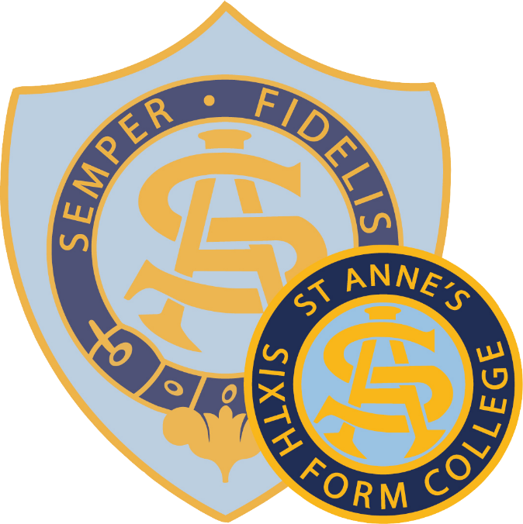

St Anne’s Catholic School and Sixth Form College

Pastoral Systems

September 2020

Introduction
The COVID-19 situation means that we have to think afresh about how we support one another and behave on site. None of the school policies has changed but it is important to know how the school policies are interpreted in a school that will look very different but hopefully still feel like the same St Anne’s.
The relevant policies, available on the school website, are:
- Safeguarding policy
- Behaviour policy
Our school vision statement reminds us of the importance of responding to a rapidly changing world while maintaining the core principles of our school community. We have never known change like this before and so as a school, we commit to:
- revealing God’s love in all we do
- keeping education at the heart of decision-making
- helping all members of the community to continue to grow each day in holiness
- remaining a family community
- empowering all members of the community, however hard they are finding this situation
- remembering that all the universe is inter-connected
- maintaining our LSU identity, seen through the SHOW values.
Pastoral care is the responsibility of every member of the school community. Staff all need to take responsibility for resolving problems even more so when students cannot easily be sent somewhere to speak to someone. Students need to look out for each other as they do so well. Parents need to keep in touch with the school about things that are worrying them.

Safeguarding
Safeguarding policies and procedures continue to apply and the DSL is available for formal or informal conversations when anyone is worried about a young person. In the event that we or part of the school must operate remotely, the remote working COVID procedures will apply. Non-staff members may always email concerns to safe@st-annes.uk.com.
In order to facilitate the ability for the DSL and his core staff to understand the ‘big picture’ of young people’s lives, including their mental health, the following specific actions will take place during the autumn term:
- compulsory mental health/transition back to school briefing for staff, teaching and support, alongside safeguarding policy review in September 2020
- roll out of CPOMS to all staff, teaching and support, for the recording of safeguarding concerns and pastoral concerns in September 2020

Attendance
Attendance becomes compulsory again in September. On arrival, students may go to any normal classroom tutor base in their year group hub or to their year group outdoor space (the year group indoor space is only available in bad weather). Those tutor groups that are based in science labs may go to their classroom at 8.30 but may not go in until their tutor arrives.
We understand that some families may find the return to school worrying. Work has been taking place over the summer with some identified families and the attendance officer and heads of year will initially take the approach of working with families and young people to understand the measures the school has put in place to ensure the safety of all, following the government’s guidance. The September reopening section on the school website gives a good overview of the systems that will be in place.
Absence can be notified by emailing attendance@st-annes.uk.com stating the child’s name, tutor group and reason for absence. The email address used must match that on the system for the parent – this will be the email address that parents receive emails from the school on. If parents need to change their details, they should email info@st-annes.uk.com and we will contact them for verification.
All students who are late will be marked as such in the register. Lateness will be unauthorised unless there is evidence of an external appointment presented (e.g. an appointment slip). We will monitor disruption to public transport and pupil journeys as required. Repeated lateness with no appropriate reason will lead to an after-school detention.
Staff need to be vigilant to attendance within their subject lessons and take proactive steps to help students to catch up who have been away, especially where there are more double or triple lessons when students may have missed significant work.

Behaviour
The school has made a number of adjustments to the way that we work and the following are examples of how the code of conduct will be applied to the new circumstances from September.
Be punctual | Move efficiently between classes at the correct time. Some lesson changeovers will be staggered for safety reasons and it will be important to follow these rules.
Be co-operative | Sometimes staff will need to request that students do something they do not expect and students must remember the importance of following the requests of adults immediately so as not to put others in any danger.
Be considerate | Others in the community may feel anxious about COVID-19 or have experienced loss in their lives. We expect all students to consider how their words or actions might affect others.
Be focused | Some lessons will be longer to avoid moving around the site too much. We expect students to concentrate in full even in these longer lessons.
Be ambitious | Even if we have to conduct some learning remotely, we expect all students to aim high and to try to achieve through completing and submitting work in all their subjects to the best of their ability.
Whenever you are in uniform you represent our community | It is important that members of the public understand that St Anne’s students are good citizens. No behaviour on the way to or from school should bring the school into disrepute. This includes following safety requirements in shops, on public transport and so on.
Respect yourself | All students should follow government guidance as well as school guidance. The school will only ever follow government guidance.
Respect others | Be aware of those around you and do not use COVID-19 as a way of upsetting other people.
Respect the environment | Students will be spending more time in classrooms than they are used to. All rooms should be treated with absolute respect, leaving them clean and tidy with furniture replaced.

Sanctions
It is important to be clear with all students that behaviour that is a serious breach of the code of conduct (such as the examples above but not just these), behaviour that brings the school into disrepute and behaviour that endangers the health and safety of others can lead to fixed term exclusion. Repeated breaches can lead to permanent exclusion. To protect members of the school community, students should know that the school will use these sanctions to protect others.
Some other examples of issues that occur might include students who go out of their assigned areas, students who pretend to have COVID-19 symptoms, students who refuse to socially distance themselves from those in other year groups or staff or the misuse of face coverings. No list can be exhaustive.
Other school day-to-day sanctions will continue to apply with the following adjustments. All will be recorded on SIMS as usual.
- Extra work with accompanying note in log book from the class teacher to be completed by a particular time. This work could include copying out the code of conduct or vision statement or doing non-subject-related tasks.
- Detention set for break or half a lunch time by any member of staff – this will need to take place in the year group area. A student may be required to sit separately from the rest of the students in a room and carry out a piece of work.
- Detention set for after school by any head of department or head of year – for a maximum of 30 minutes. This takes place in the year group area and will take place on the next school day or afterwards, communicated through the log book. Supervision is organised by the member of staff setting the detention.
- School detentions for 60 minutes (Tuesdays) or 30 minutes (Wednesdays – for lates) or 90 minutes (Fridays) in the Lecture Theatre. Referral for these are by middle/senior leaders (Tuesdays) or senior leaders (Fridays) as usual via SIMS. This will be cross-year group and conducted socially distanced between year groups. Students will remain standing if a cleaner needs to sanitise an area before use. These are supervised by SLT and an email is sent home in advance as usual.
- The isolation room will continue to operate as usual. Students in isolation do not leave during the day and so create their own hub for the day. Students in isolation will be dismissed at 3.35 to keep them separate from those who have been in year group hubs during the day and escorted to the gate. Students entering isolation during the day will do so at the discretion of a member of SLT. They will either be socially distanced in the isolation room or else remain supervised by an SLT member elsewhere for the remainder of the day.
- The on call system will continue to run. All staff will be aware of the designated buddy room for each period in the hub area and will use this intervention first where possible. If on call is used, the decision will be taken whether to return the student to the lesson, to the buddy room or to take them to the hub for a maximum of 10 minutes after which if the student does not comply, further action will be taken. The on call staff will immediately email the teacher, the head of department, the head of year and all SLT to inform them of actions taken.
- Parent meetings can continue to run as usual. The meeting room in reception is set up to allow social distancing for up to two members of staff and up to two family members. Where practical and safe, meetings can also take place outside the main door to school.

Rewards
We know that the vast majority of St Anne’s students will be happy to contribute fully to making the school safe and it will always be the aim of staff members to educate before sanctioning. The school rewards system will continue in full from September and LSU merits may be awarded for showing the LSU values in any situation, including those new to the community as a result of COVID-19.

Pastoral Support
The tutor remains the first point of contact for all students and parents for the majority of situations. The tutor can be emailed via info@st-annes.uk.com or contacted through a message in the student log book. Where there is a concern about a subject, parents should email info@st-annes.uk.com and mark the email for the attention of the subject teacher or head of department. Heads of Year can also be contacted by email through the same address. There is a two working day turnaround in most cases for email communication. A telephone message may be left for the Head of Year where the matter is more urgent.
We want parents to feel able to contact the school about anything that is worrying them about their child or about their families. School has access to a number of different support systems outside of school for other members of families as well as the students. It will also help us to understand and support the young person in school.
School has a large but still limited number of appointments available with different levels of counsellors or mental health supporters. There is never any shame or anything wrong with needing to speak to someone about something that is bothering us but sadly we cannot offer appointments to everyone and may need to support parents with contacting external agencies themselves for support. All counselling sessions will take place 1:1 in a socially distanced and regularly-cleaned environment. Any group sessions that take place in school will take place only with those in the same year group.

The Hub
The pastoral hub remains the base for heads of years 7-11 but students should only attend in cases of need. The heads of year will be present in year group areas during social times when they can. Uniform issues will still be looked after in the nurture room during morning registration. Students will need to be responsible and queue in a socially distanced way when attending the hub. Students are unlikely to be allowed to remain in the hub.
Students attending the hub or the Sixth Form office should respect the need of staff to remain socially distanced.

Nurture Room
The nurture room is only available for students directed there by the inclusion lead or in exceptional circumstances by a member of staff in the hub. Students will remain in there for a limited amount of time as directed by the inclusion lead. Social distancing between year groups will be maintained. Where there are too many students in the room, the decision of the supervising member of staff in there will be final. The nurture room is not available for students to visit during break or lunch times.

Students requiring adjustments
All decisions will be taken on an individual basis and the decision will involve the SENCO, Inclusion Lead and Business Manager as appropriate. Where students for medical reasons cannot attend all lessons, we will continue to strive to give them a full education as usual. However, the limitations of the site with the restrictions post-COVID-19 might mean that the reasonable adjustments could include:
- being part of a different hub than the remainder of the year group, with no option to mix hubs during the day (e.g. where a year group does not have a ground floor classroom, a student may be required to sit with a different year group while they recover)
- attending all lessons in the ground floor classroom of a year group hub (where one exists) and carrying out work from other lessons while in that room
- working from home using Teams or pre-set work from subject teachers
- working under the supervision of an HLTA (or class teacher where the HLTA can facilitate the remainder of the lesson) in a different space (e.g. the nurture room where stairs are not an issue)

Uniform, PE Kit and Lockers
School uniform will be worn in full from the first day of term. Lockers will not be available for use for years 7 to 11 during COVID-19 restrictions. This will mean that students will need to store books they do not need on a particular day at home. Arrangements will be made for lockers to be visited on the first day of term for any girls who have left items in there since closure.
A large amount of lost property has been kept safe during closure and is available for collection. Damp swimming items were washed but may have been separated from bags.
Depending on the timetable arrangements, some girls may be required to wear their PE kit to and from school on specific days to ensure that changing facilities can be kept safe. This information will be communicated to the relevant classes by the PE department. PE or swimming kit should be carried with students during the day to avoid having to disturb other lessons when they need to collect kit.
When the weather requires coats, students will be permitted to carry these with them but they may not be worn during lessons. Coats may be stored during the day in the tutor base in an area agreed with the tutor.

Use of tutor bases
Girls in years 7 to 11 will be spending more of their time in a limited area. Tutor bases may be used from 8.30am or during break and lunch. Each year group will have an assigned outdoor space for these times which can also be accessed. Wet weather breaks will be signalled by two rings of the school bell fifteen minutes before the end of the previous lesson. Girls will have allocated indoor spaces that will be available during these times. Years 10 and 11 may use either the wet or dry spaces at all times.
Respectful use of tutor bases is vital to the safety and smooth running of the school. Mixing between year groups is, of course, not possible at this time.

