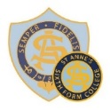Admission Through Musical Aptitude Guidance Sheet part 1
Year 7 September 2021 (Please see the next page for details of changes due to Coronavirus.)
We encourage pupils with a love of, and talent for, music to apply for a place at St Anne’s on the basis of musical aptitude. Our music department is excellent and provides outstanding opportunities for your daughter while she is a pupil at St Anne’s.
When is the assessment?
- Thursday 17th September 2020 at 3.45pm.
- Parents must wait in school while their child takes the assessment.
If you wish for your daughter to sit the musical aptitude test you must contact the Admissions Officer by email (admissions@st-annes.uk.com) or phone to inform them of this by Monday 14th September 2020

- The assessment does not require any previous coaching or instrumental lessons.
- The assessment will take approximately 45 minutes.
- There will be 60 questions in a total.
- All answers are multiple choice.
- The assessment has four sections: Pitch, Melody, Texture and Rhythm.

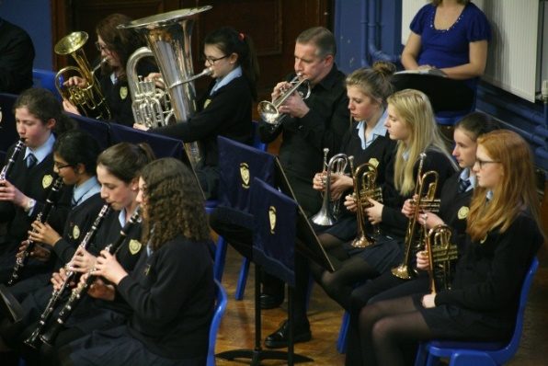

When will I know if my daughter has been successful?
- You will be contacted by the school by the end of September by email. If we do not hold an email address for you, we will contact you by letter.

The assessment in detail…
- Pitch: 20 questions. Candidates will hear two sounds and have to indicate whether the second sound is the same as the first, higher or lower than the first.
- Melody: 10 questions. Candidates will hear two tunes consisting of five notes and have to indicate whether the second is the same or different from the first. If a note has been altered, candidates will be expected to identify which note, by giving the number.
- Texture: 20 questions. Candidates will hear a number of notes played together at the same time and have to indicate whether they can hear two, three or four pitches.
- Rhythm: 10 questions. Candidates will hear two four beat rhythms and have to decide whether the second pattern is the same as, or different from, the first and where any difference occurs.

My daughter needs special consideration because of medical or Special Educational Needs
- Parents should write to the Admissions Officer (admissions@st-annes.uk.com) by Monday 14th September 2020.
- Enclose/attach a doctor’s certificate explaining medical needs or a letter from your current school as evidence of Special Educational Needs requiring special consideration during the testing.
- If a candidate is ill, please contact the Admissions Officer (admissions@st-annes.uk.com) and obtain a doctor’s certificate with evidence of illness on the test date and submit this evidence.
- If a candidate fails to notify the school that they cannot attend on Thursday 17th September 2020 due to illness or fails to produce a doctor’s certificate, she cannot be considered by the Governors in this category.

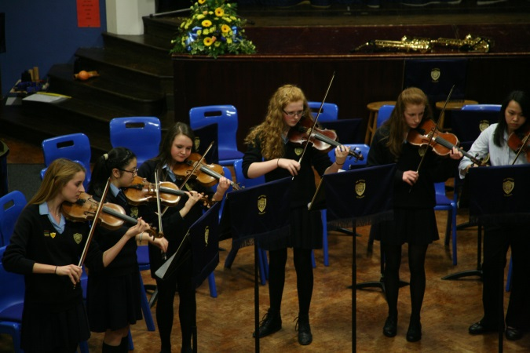
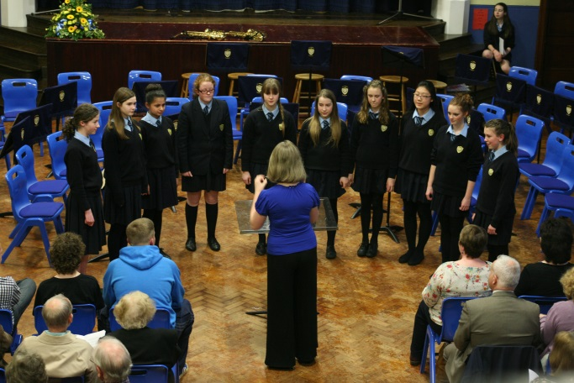
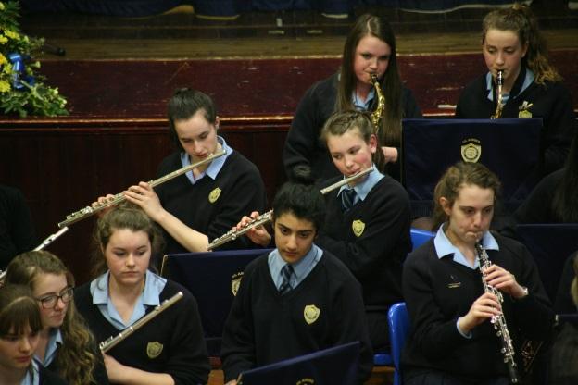

Musical Aptitude Test Guidance part 2 2021-2022
Musical aptitude tests will take place on Thursday 17th September 2020 (when your daughter is in Year 6). If you wish for your daughter to sit the musical aptitude test you must contact the Admissions Officer by email (admissions@st-annes.uk.com) or phone to inform them of this by Monday 14th September 2020. There will be an additional test date in case of illness of a candidate. This will only be available to candidates who are ill on the 17th September 2019, evidenced by written medical certificate.
Admission Through Musical Aptitude : Year 7 September 2021
Change made in July 2020 due to Coronavirus restrictions:
If you are self-isolating you must follow the NHS advice and you must not attend the school site.
It is recommended that written tests continue to run under exam conditions wherever possible. Musical aptitude tests will continue to take place on Thursday 17th September 2020 (when your daughter is in Year 6). If you wish for your daughter to sit the musical aptitude test you must contact the Admissions Officer by email (admissions@st-annes.uk.com) or phone to inform them of this by Monday 14th September 2020.
Changes:
Parents will not be permitted to park at the school and should use public parking nearby. This is to avoid congregation of parents and candidates.
Candidates and families will not be able to congregate in groups whilst entering or leaving the school.
Social distancing will be in place for all candidates. Candidates will arrive and will be seated at their desk until the test starts. All candidates will need to use hand sanitiser prior to the test. Hand sanitiser will be provided by the school. Candidates will not be able to mix with other pupils on site.
Candidates will need to bring their own full water bottle, pencil and pen. Spare, unused/sanitised stationary will be available for any candidate who needs it.
Parents will be seated in the hall in family groups whilst their child completes the test. Social distancing will be in place. We ask that where possible, only one parent accompanies their child to reduce the number of people on site. No toilet facilities will be available except where there is a medical need evidenced by a letter from a medical professional or a toilet card.
The additional test date in case of illness will be available to assess those who on 17th September cannot attend due to coronavirus (such as self-isolation due to illness or exposure to someone who is ill, or local protective measures) as well as those who are ill for other reasons. The requirement for a medical written certificate has been removed and parents should contact the school by 5pm (by phone or email admissions@st-annes.uk.com) on 17th September if their child is unable to sit the test due to coronavirus or illness. Failure to do so by the deadline will mean that they will not be eligible to sit the test on the additional test date. Candidates who are unable to sit the test on 17th September for another reason (including but not limited to going on a school trip or a dental appointment) will not be eligible to sit the test on the additional test date. The additional test date is planned for 8th October at 3.45pm to allow for the maximum possible period of time self-isolating https://assets.publishing.service.gov.uk/government/uploads/system/uploads/attachment_data/file/874011/Stay_at_home_guidance_diagram.pdf

This is for admission to the school at the start of the school year in September and not for applications made in-year.

