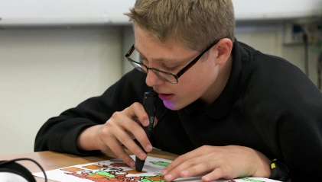
Does your child have a vision impairment?
If so, you are invited to our NEW support group for parents/carers.

Specialist Teacher Advisors will be present
Parents Support Group
Make connections
Vision impairment

Thursday March 7th 2019
10 am – 12 noon
Pickles Coppice Children’s Centre
All ages welcome!
Stay and Play Session
65 Windermere Ave, Southampton SO16 9QX

Wednesday March 20th 2019
10 am - 12 noon
Townhill Park Sure Start Centre
Cutbush Lane (Townhill Park Jr School grounds) SO18 2GF

Please come along to our new support group
(Preschool children are welcome to attend)
For more information please contact Diana on 07985761983

