Admission Through Musical Aptitude
(for girls in Year 6 in Oct 2018)

We encourage pupils with a love of, and talent for, music to apply for a place at St Anne’s on the basis of musical aptitude. Our music department is excellent and provides outstanding opportunities for your daughter while she is a pupil at St Anne’s.
- The assessment does not require any previous coaching or instrumental lessons.
- The assessment will take approximately 45 minutes.
- There will be 60 questions in a total.
- All answers are multiple choice.
- The assessment has four sections: Pitch, Melody, Texture and Rhythm.

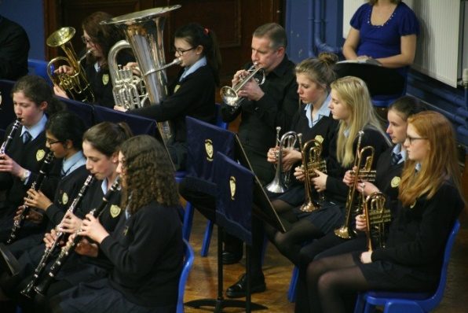
When is the assessment?
- Wednesday 28th November at 3.45pm.
- Parents may wait in school while their child takes the assessment.

When will I know if my daughter has been successful?
- You will be contacted by the School at the beginning of March.

The assessment in detail…
- Pitch: 20 questions. Candidates will hear two sounds and have to indicate whether the second sound is the same as the first, higher or lower than the first.
- Melody: 10 questions. Candidates will hear two tunes consisting of five notes and have to indicate whether the second is the same or different from the first. If a note has been altered, candidates will be expected to identify which note, by giving the number.
- Texture: 20 questions. Candidates will hear a number of notes played together at the same time and have to indicate whether they can hear two, three or four pitches.
- Rhythm: 10 questions. Candidates will hear two four beat rhythms and have to decide whether the second pattern is the same as, or different from, the first and where any difference occurs.

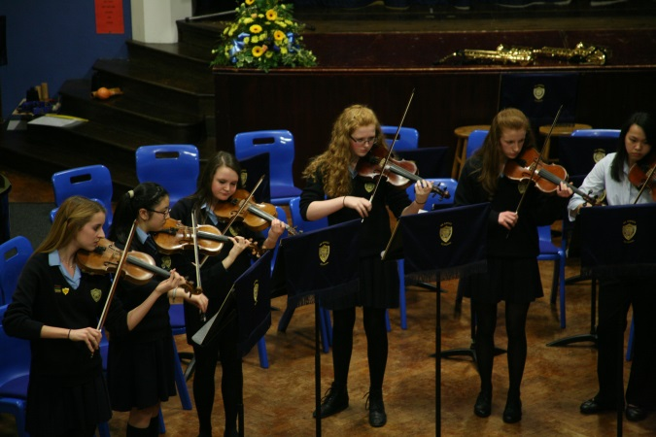
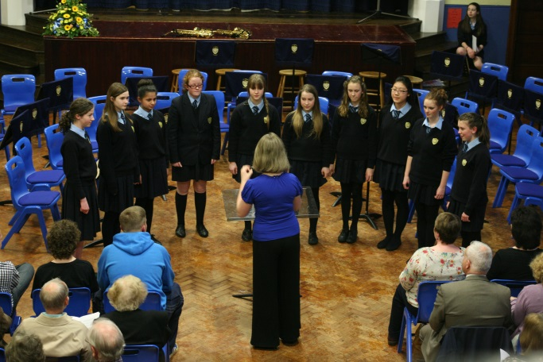
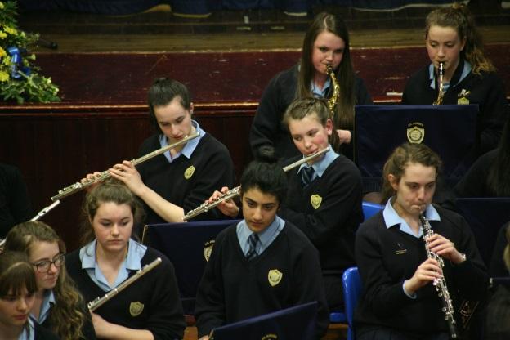
My daughter needs special consideration because of medical or Special Educational Needs
- Parents should write to Mrs. Langford at St Anne’s by Wednesday 21st November 2018.
- Enclose a doctor’s certificate explaining medical needs or a letter from your current school as evidence of Special Educational Needs requiring special consideration during the testing.
- If a candidate is ill, please contact Mrs. F Langford and obtain a doctor’s certificate.
- If an applicant fails to notify the school that they cannot attend on Wednesday 28th November or fails to produce a doctor’s certificate, she cannot be considered by the Governors in this category.

